SCSE

SUBJECT: Cyber Security

B.E. Year – 3 Semester

LAB MANUAL
Prepared By:
Surendra Singh Chauhan
July, 2021

 | Unit I
S.no | Name of the practical
1 | Perform the practical of Caesar Cipher  Perform the practical of Playfair algorithm
2 | Perform the practical of Hill Cipher
3 | Perform the practical of Diffie hellman key exchange algorithm.  Perform the practical of RSA algorithm
4 | Perform the modes
 | Unit II
5 | Perform the practical of MD5
6 | Perform the practical of SHA1
7 | Perform the practical of digital signature on text
 | Unit III
9 | Perform the practical to generate digital certificate
10

EXPERIMENT-1
AIM: To Perform Caeser Cipher

CODE:
#include<stdio.h>
#include<conio.h>
void main()
{
char a[10];
int z,i,x[10],c[10],d[10],u,m[i];
printf("Enter the skips: ");
scanf("%d",&u);
printf("Enter any string of length 10: ");
for(i=0;i<10;i++)
{
scanf("%s",&a[i]);
}
// printf("\nORIGINAL STRING:%s \n\n",a);
for(i=0;i<10;i++) //Encrypt
{
x[i]=a[i];
if(x[i]>=88)
{
c[i]=x[i]-26+u;
}
else
{
c[i]=x[i]+u;
}

}
printf("Cipher text:");
for(i=0;i<10;i++)
printf("%c",c[i]);

//DECRYPT
for(i=0;i<10;i++)
{
x[i]=c[i];
if(x[i]<=67){

d[i]=x[i]+26-u;}
else{

d[i]=x[i]-u;
}
}
printf("\nDeciphered text: ");
for(i=0;i<10;i++)
{
printf("%c",d[i]);
}

//Brute Force
for(z=0;z<26;z++)
{

for(i=0;i<10;i++)
{
x[i]=c[i];
if(x[i]<65+z)
{

m[i]=x[i]+26-z;
}
else{

m[i]=x[i]-z;
}
}
printf("\nPLAIN text:\n");
for(i=0;i<10;i++)
printf("%c",m[i]);
}

getch();
}

OUTPUT:
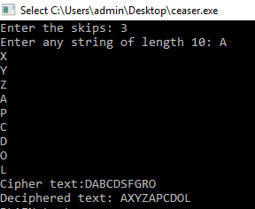

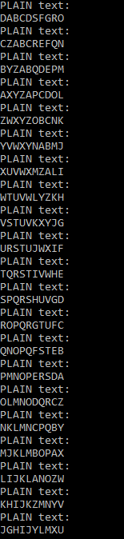

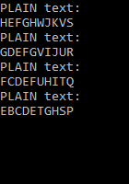

EXPERIMENT-2

AIM: To Perform Diffie-Hellman Algorithm
CODE:
#include<stdio.h>
long long int power(int a,int b,int mod)
{
long long int t;
if(b==1)
return a;
t=power(a,b/2,mod);
if(b%2==0)
return (t*t)%mod;
else
return (((t*t)%mod)*a)%mod;
}
long long int calculateKey(int a,int x,int n)
{
return power(a,x,n);
}
int main()
{
int n,g,x,a,y,b;
// both the persons will be agreed upon the common n and g
printf("Enter the value of n and g : ");
scanf("%d%d",&n,&g);

// first person will choose the x
printf("Enter the value of x for the first person : ");
scanf("%d",&x);
a=power(g,x,n);

// second person will choose the y
printf("Enter the value of y for the second person : ");
scanf("%d",&y);
b=power(g,y,n);

printf("key for the first person is : %lld\n",power(b,x,n));
printf("key for the second person is : %lld\n",power(a,y,n));
return 0;
}
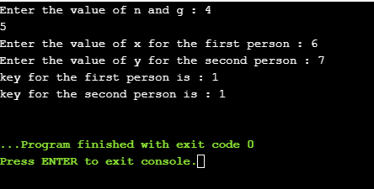
OUTPUT:

EXPERIMENT-3
Aim: To Perform Playfair Cipher Algorithm
CODE:
#include <iostream>
#include <string>
using namespace std;
class playfair {
public:
string msg; char n[5][5];
void play( string k, string t, bool m, bool e ) {
createEncoder( k, m );
getText( t, m, e );
if( e )
play( 1 );
else
play( -1 );
print();
}
private:
void play( int dir ) {
int j,k,p,q;
string nmsg;
for( string::const_iterator it = msg.begin(); it != msg.end(); it++ ) {
if( getPos( *it++, j, k ) )
if( getPos( *it, p, q) {
//for same row
if( j == p ) {
nmsg+= getChar( j, k + dir );
nmsg += getChar( p, q + dir );
}
//for same column
else if( k == q ) {
nmsg += getChar( j + dir, k );
nmsg += getChar( p + dir, q );
} else {
nmsg += getChar( p, k );
nmsg += getChar( j, q );
}
}
}
msg = nmsg;
}
void print() //print the solution {
cout << "\n\n Solution:" << endl;
string::iterator it = msg.begin(); int count = 0;
while( it != msg.end() ) {
cout << *it;
it++;
cout << *it << " ";
it++;
if( ++count >= 26 )
cout << endl;
count = 0;
}
cout << endl << endl;
}
char getChar( int a, int b ) { //get the characters
return n[ (b + 5) % 5 ][ (a + 5) % 5 ];
}
bool getPos( char l, int &c, int &d ) { //get the position
for( int y = 0; y < 5; y++ )
for( int x = 0; x < 5; x++ )
if( n[y][x] == l ) {
c = x;
d= y;
return true;
}
return false;
}
void getText( string t, bool m, bool e ) { //get the original message
for( string::iterator it = t.begin(); it != t.end(); it++ ) {
//to choose J = I or no Q in the alphabet.
*it = toupper( *it );
if( *it < 65 || *it > 90 )
continue;
if( *it == 'J' && m )
*it = 'I';
else if( *it == 'Q' && !m )
continue;
msg += *it;
}
if( e ) {
string nmsg = ""; size_t len = msg.length();
for( size_t x = 0; x < len; x += 2 ) {
nmsg += msg[x];
if( x + 1 < len ) {
if( msg[x] == msg[x + 1] ) nmsg += 'X';
nmsg += msg[x + 1];
}
}
msg = nmsg;
}
if( msg.length() & 1 )
msg += 'X';
}
void createEncoder( string key, bool m ) { //creation of the key table
if( key.length() < 1 )
key= "KEYWORD";
key += "ABCDEFGHIJKLMNOPQRSTUVWXYZ";
string s= "";
for( string::iterator it = key.begin(); it != key.end(); it++ ) {
*it = toupper( *it );
if( *it < 65 || *it > 90 )
continue;
if( ( *it == 'J' && m ) || ( *it == 'Q' && !m ) )
continue;
if( s.find( *it ) == -1 )
s += *it;
}
copy( s.begin(), s.end(), &n[0][0] );
}
};
int main( int argc, char* argv[] ) {
string k, i, msg;
bool m, c;
cout << "Encrpty or Decypt? ";
getline( cin, i );
c = ( i[0] == 'e' || i[0] == 'E' );
cout << "Enter a key: ";
getline( cin, k);
cout << "I <-> J (Y/N): ";
getline( cin, i );
m = ( i[0] == 'y' || i[0] == 'Y' );
cout << "Enter the message: ";
getline( cin, msg );
playfair pf;
pf.play( k, msg,m, c );
return system( "pause" );
}

OUTPUT:

Encrpty or Decypt? e
Enter a key: players
I <-> J (Y/N): y
Enter the message: This is tutorialspoint

Solution:
OK GC GC MZ MQ CF YA RL QH OM

EXPERIMENT-4

Aim: To Perform Rivest-Shamir-Adleman (RSA) Algorithm
CODE:
// C program for RSA asymmetric cryptographic
// algorithm. For demonstration values are
// relatively small compared to practical
// application
#include<stdio.h>
#include<math.h>

// Returns gcd of a and b
int gcd(int a, int h)
{
int temp;
while (1)
{
temp = a%h;
if (temp == 0)
return h;
a = h;
h = temp;
}
}

// Code to demonstrate RSA algorithm
int main()
{
// Two random prime numbers
double p = 3;
double q = 7;

// First part of public key:
double n = p*q;

// Finding other part of public key.
// e stands for encrypt
double e = 2;
double phi = (p-1)*(q-1);
while (e < phi)
{
// e must be co-prime to phi and
// smaller than phi.
if (gcd(e, phi)==1)
break;
else
e++;
}

// Private key (d stands for decrypt)
// choosing d such that it satisfies
// d*e = 1 + k * totient
int k = 2; // A constant value
double d = (1 + (k*phi))/e;

// Message to be encrypted
double msg = 20;

printf("Message data = %lf", msg);

// Encryption c = (msg ^ e) % n
double c = pow(msg, e);
c = fmod(c, n);
printf("\nEncrypted data = %lf", c);

// Decryption m = (c ^ d) % n
double m = pow(c, d);
m = fmod(m, n);
printf("\nOriginal Message Sent = %lf", m);

return 0;
}

OUTPUT:
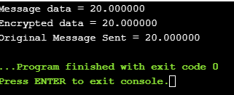

EXPERIMENT-5
AIM: WAP on Cipher Block Chaining
CODE:

import java.util.*;
import java.nio.charset.Charset;

class Main {
private static final Charset UTF_8 = Charset.forName("UTF-8"); public static void main(String[] args) {
Scanner sc = new Scanner(System.in); System.out.print("Enter the text for conversion : "); String text = sc.nextLine();
String keys;
boolean continueLoop = true; do {
System.out.print("Enter 8 character key for conversion : "); keys = sc.nextLine();
if(keys.length() == 8) { continueLoop = false;
}
}while(continueLoop); continueLoop = true; String iVs;
do {
System.out.print("Enter 8 character IV for conversion : "); iVs = sc.nextLine();
if(iVs.length() == 8) { continueLoop = false;
}
}while(continueLoop);
byte[] bytes = text.getBytes(UTF_8); byte[] key = keys.getBytes(UTF_8); byte[] iV = iVs.getBytes(UTF_8);

System.out.println(" ");
System.out.println("Original text = " + new String(bytes, UTF_8)); System.out.println("Original bytes = "+ Arrays.toString(bytes)); for(int i = 0; i < bytes.length; i++) {
bytes[i] = (byte)(bytes[i] ^ iV[i % 8]);
bytes[i] = (byte)(bytes[i] ^ key[i % 8]); if(i % 8 == 7) {
for(int j = i - 7; j <= i; j++) { iV[j % 8] = bytes[j];
}
}
}

System.out.println(" ");
System.out.println("Transformed text = "+new String(bytes, UTF_8)); System.out.println("Transformed bytes = "+ Arrays.toString(bytes));

byte[] temp = new byte[8];
for(int i = 0; i < bytes.length; i++) { temp[i] = (byte)bytes[i];
if(i == 7) { break;
}
}

for(int i = 0; i < bytes.length; i++) { bytes[i] = (byte)(bytes[i] ^ key[i]);
bytes[i] = (byte)(bytes[i] ^ iV[i]); if(i == 7) {
break;
}
}

for(int i = 8; i < bytes.length; i++) { if(i % 8 == 0) {
for(int j = 0; j < 8; j++) { iV[j] = temp[j];
temp[j] = bytes[j + i];
}
}
bytes[i] = (byte)(bytes[i] ^ key[i]);
bytes[i] = (byte)(bytes[i] ^ iV[i]);
}

System.out.println(" ");
System.out.println("Original text again= "+new String(bytes, UTF_8)); System.out.println("Original bytes = "+ Arrays.toString(bytes));
}
}
OUTPUT:
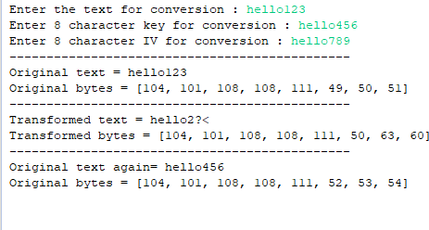

EXPERIMENT-6
AIM: WAP on Electronic Code Book
CODE:
import java.util.*;
import java.nio.charset.Charset;

class Main {
private static final Charset UTF_8 = Charset.forName("UTF-8"); public static void main(String[] args) {
Scanner sc = new Scanner(System.in); System.out.print("Enter the text for conversion : "); String text = sc.nextLine();
String keys;
boolean continueLoop = true; do {
System.out.print("Enter 8 character key for conversion : "); keys = sc.nextLine();
if(keys.length() == 8) { continueLoop = false;
}
}while(continueLoop);
byte[] bytes = text.getBytes(UTF_8); byte[] key = keys.getBytes(UTF_8);
System.out.println(" ");
System.out.println("Original text = " + new String(bytes, UTF_8)); System.out.println("Original bytes = "+ Arrays.toString(bytes)); for(int i = 0; i < bytes.length; i++) {
bytes[i] = (byte)(bytes[i] ^ key[i % 8]);
}

System.out.println(" ");
System.out.println("Transformed text = "+new String(bytes, UTF_8)); System.out.println("Transformed bytes = "+ Arrays.toString(bytes));

for(int i = 0; i < bytes.length; i++) { bytes[i] = (byte)(bytes[i] ^ key[i % 8]);
}

System.out.println(" ");
System.out.println("Original text again= "+new String(bytes, UTF_8)); System.out.println("Original bytes = "+ Arrays.toString(bytes));
}
}
OUTPUT:
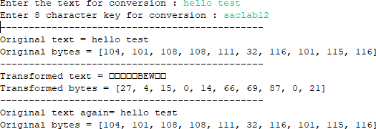

EXPERIMENT-7
AIM: WAP on Digital Signature
CODE:
import random
from hashlib import sha256

def coprime(a, b): while b != 0:
a, b = b, a % b return a

def extended_gcd(aa, bb):
lastremainder, remainder = abs(aa), abs(bb) x, lastx, y, lasty = 0, 1, 1, 0
while remainder:
lastremainder, (quotient, remainder) = remainder, divmod(lastremainder, remainder) x, lastx = lastx - quotient*x, x
y, lasty = lasty - quotient*y, y
return lastremainder, lastx * (-1 if aa < 0 else 1), lasty * (-1 if bb < 0 else 1)

#Euclid's extended algorithm for finding the multiplicative inverse of two numbers def modinv(a, m):
g, x, y = extended_gcd(a, m) if g != 1:
raise Exception('Modular inverse does not exist') return x % m

def is_prime(num): if num == 2:
return True
if num < 2 or num % 2 == 0: return False
for n in range(3, int(num**0.5)+2, 2): if num % n == 0:
return False return True

def generate_keypair(p, q):
if not (is_prime(p) and is_prime(q)):
raise ValueError('Both numbers must be prime.') elif p == q:
raise ValueError('p and q cannot be equal')

n = p * q

#Phi is the totient of n phi = (p-1) * (q-1)

#Choose an integer e such that e and phi(n) are coprime e = random.randrange(1, phi)

#Use Euclid's Algorithm to verify that e and phi(n) are comprime g = coprime(e, phi)

while g != 1:
e = random.randrange(1, phi) g = coprime(e, phi)

#Use Extended Euclid's Algorithm to generate the private key d = modinv(e, phi)

#Return public and private keypair
#Public key is (e, n) and private key is (d, n) return ((e, n), (d, n))

def encrypt(privatek, plaintext): #Unpack the key into it's components key, n = privatek
#Convert each letter in the plaintext to numbers based on the character using a^b mod m numberRepr = [ord(char) for char in plaintext]
print("Number representation before encryption: ", numberRepr) cipher = [pow(ord(char),key,n) for char in plaintext]

#Return the array of bytes return cipher

def decrypt(publick, ciphertext): #Unpack the key into its components key, n = publick

#Generate the plaintext based on the ciphertext and key using a^b mod m numberRepr = [pow(char, key, n) for char in ciphertext]
plain = [chr(pow(char, key, n)) for char in ciphertext] print("Decrypted number representation is: ", numberRepr)
#Return the array of bytes as a string return ''.join(plain)

def hashFunction(message):
hashed = sha256(message.encode("UTF-8")).hexdigest() return hashed

def verify(receivedHashed, message): ourHashed = hashFunction(message) if receivedHashed == ourHashed:
print("Verification successful: ", ) print(receivedHashed, " = ", ourHashed)
else:

print("Verification failed") print(receivedHashed, " != ", ourHashed)

def main():
p = int(input("Enter a prime number (17, 19, 23, etc): "))
q = int(input("Enter another prime number (Not one you entered above): ")) #p = 17
#q=23

print("Generating your public/private keypairs now . . .") public, private = generate_keypair(p, q)

print("Your public key is ", public ," and your private key is ", private) message = input("Enter a message to encrypt with your private key: ") print("")

hashed = hashFunction(message)

print("Encrypting message with private key ", private ," . . .") encrypted_msg = encrypt(private, hashed)
print("Your encrypted hashed message is: ") print(''.join(map(lambda x: str(x), encrypted_msg))) #print(encrypted_msg)

print("")
print("Decrypting message with public key ", public ," . . .")

decrypted_msg = decrypt(public, encrypted_msg) print("Your decrypted message is:") print(decrypted_msg)

print("")
print("Verification process . . .") verify(decrypted_msg, message)

main()

OUTPUT:
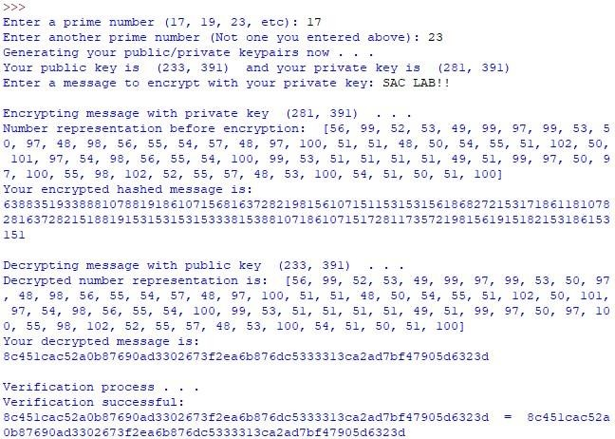

EXPERIMENT-8
AIM: To Perform Hill Cipher

CODE:
#include<iostream>
#include<math.h>

using namespace std;
float en[3][1], de[3][1], a[3][3], b[3][3], msg[3][1], m[3][3];
void getKeyMatrix() {

int i, j;
char mes[3];
cout<<"Enter 3x3 matrix for key (should have inverse for decryption purpose):\n";
for(i = 0; i < 3; i++)
for(j = 0; j < 3; j++) {
cin>>a[i][j];
m[i][j] = a[i][j];
}
cout<<"\nEnter a string of 3 letter(use A through Z): ";
cin>>mes;
for(i = 0; i < 3; i++)
msg[i][0] = mes[i] - 65;
}
void encrypt() {
int i, j, k;
for(i = 0; i < 3; i++)
for(j = 0; j < 1; j++)
for(k = 0; k < 3; k++)
en[i][j] = en[i][j] + a[i][k] * msg[k][j];
cout<<"\nEncrypted string is: ";
for(i = 0; i < 3; i++)
cout<<(char)(fmod(en[i][0], 26) + 65);
}
void inversematrix() {
int i, j, k;
float p, q;
for(i = 0; i < 3; i++)
for(j = 0; j < 3; j++) {
if(i == j)
b[i][j]=1;
else
b[i][j]=0;
}
for(k = 0; k < 3; k++) {
for(i = 0; i < 3; i++) {
p = m[i][k];
q = m[k][k];
for(j = 0; j < 3; j++) {
if(i != k) {
m[i][j] = m[i][j]*q - p*m[k][j];
b[i][j] = b[i][j]*q - p*b[k][j];
}
}
}
}
for(i = 0; i < 3; i++)
for(j = 0; j < 3; j++)
b[i][j] = b[i][j] / m[i][i];
cout<<"\n\nInverse Matrix is:\n";
for(i = 0; i < 3; i++) {
for(j = 0; j < 3; j++)
cout<<b[i][j]<<" ";
cout<<"\n";
}
}
void decrypt() {
int i, j, k;
inversematrix();
for(i = 0; i < 3; i++)
for(j = 0; j < 1; j++)
for(k = 0; k < 3; k++)
de[i][j] = de[i][j] + b[i][k] * en[k][j];
cout<<"\nDecrypted string is: ";
for(i = 0; i < 3; i++)
cout<<(char)(fmod(de[i][0], 26) + 65);
cout<<"\n";
}
int main() {
getKeyMatrix();
encrypt();
decrypt();
}
OUTPUT:
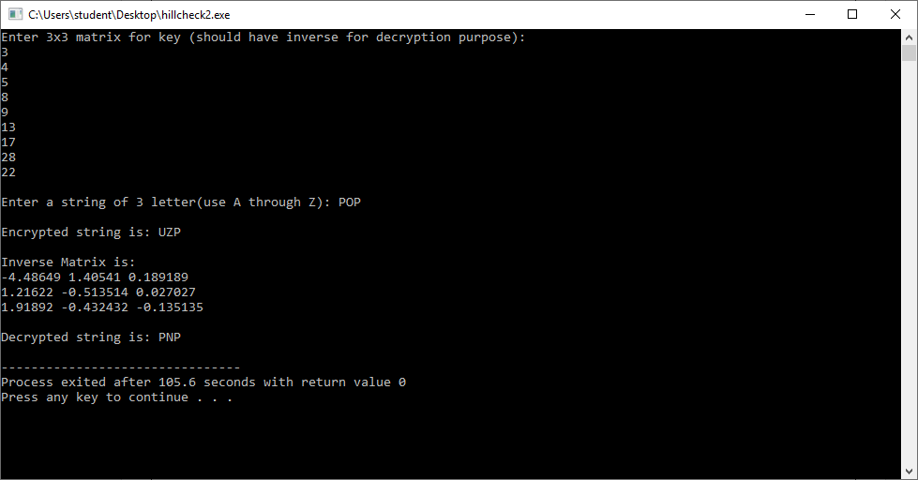

EXPERIMENT-9
AIM: To Perform Cipher Feedback mode of encryption.

CODE:
#include<iostream>
#include<math.h>
using namespace std;
int p_bit[64] ={0};
int q_bit[64] ={0};
int i,j;
int s=5;
int bin[5]={0};
string ct="";
string cipher="";
string encrypted_text="";
int iv[64] = { 1,0,1,0,1,0,1,0,
1,0,1,0,1,0,1,0,
1,0,1,0,1,0,1,0,
1,0,1,0,1,0,1,0,
1,0,1,0,1,0,1,0,

1,0,1,0,1,0,1,0,
1,0,1,0,1,0,1,0,
1,0,1,0,1,0,1,0,};
int key = 4;
void perform_encryption()
{
int i;
for(i=0;i<8;i++)
{
ct[i]+=(char)((int)ct[i]+4);
}
}
void converttostring()
{
int binary[8],rem,base=2,dec;
int c=0;

for(int j=0;j<8;j++)
{
for(int k=0;k<8;k++)
binary[k] = iv[k+c];
int i=7;
while(i>=0)
{
rem = binary[i];
dec+=rem*pow(base,7-i);
i--;
}
char ch=(char)dec;
ct+=ch;
c+=8;
}}
void converttostring_final()
{
int binary[8],rem,base=2,dec;
int c=0;
for(int j=0;j<8;j++)
{
for(int k=0;k<8;k++)
binary[k] = q_bit[k+c];
int i=7;
while(i>=0)
{
rem = binary[i];
dec+=rem*pow(base,7-i);
i--;
}
char ch=(char)dec;
cipher+=ch;
c+=8;
}}
void converttobinary(string p)
{
int ch=0;
for(int j=0;j<p.length();j++)
{
char c = p[j];
int bits[8], i;
for(i = 0; i < 8; i++)
bits[i] = ((1<<i) & c) != 0 ? 1:0;
for(i = 7; i >= 0; i--)
p_bit[7-i+ch]=bits[i];
ch+=8;
}}
void converttobinary_pt(string p)
{
int ch=0;
for(int j=0;j<p.length();j++)
{
char c = p[j];
int bits[8], i;
for(i = 0; i < 8; i++)
bits[i] = ((1<<i) & c) != 0 ? 1:0;
for(i = 7; i >= 0; i--)
q_bit[7-i+ch]=bits[i];
ch+=8;
}}
void shifter()
{
int t;
for( t=0;t<s;t++)
bin[t]=p_bit[i] ^ q_bit[i];
for(t=0;t<64;t++)
q_bit[t]=q_bit[t+s-1];
for(int t=59;t<64;t++)
q_bit[t]=bin[t-59];
}
int main()
{
string pt="Check Code";
string xt="";
converttostring();
perform_encryption();
converttobinary(ct);
converttobinary(pt);
for(i=0;i<16;i++)
{
shifter();
}
converttostring_final();
cout<<"\Your Cipher Text after cipher feedback mode encryption "<<cipher<<endl;
}
OUTPUT:
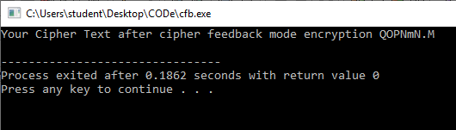

EXPERIMENT-10
AIM: To Perform Output Feedback mode of encryption.

CODE:
from Crypto.Cipher import AES
from Crypto.Random import get_random_bytes
plainText = b"Lorem ipsum dolor sit amet, consectetur adipiscing e"
key = b"ANAAREMEREAAAAAA"
def ofbEnc(plainText, key):
pos = 0
cipherTextChunks = []
iv = get_random_bytes(16)
originalIV = iv
cipher = AES.new(key, AES.MODE_ECB)
if len(plainText) % 16 != 0:
plainText += b"1"
while len(plainText) % 16 != 0:
plainText += b"0"
while pos + 16 <= len(plainText):
toXor = cipher.encrypt(iv)
nextPos = pos + 16
toEnc = plainText[pos:nextPos]
cipherText = bytes([toXor[i] ^ toEnc[i] for i in range(16)])
cipherTextChunks.append(cipherText)
pos += 16
iv = toXor
return (originalIV, cipherTextChunks)
def ofbDec(cipherTextChunks, key, iv):
plainText = b""
cipher = AES.new(key, AES.MODE_ECB)
for chunk in cipherTextChunks:
toXor = cipher.encrypt(iv)
plainText += bytes([toXor[i] ^ chunk[i] for i in range(15)])
iv = toXor
while plainText[-1] == 48:
plainText = plainText[0:-1]
if plainText[-1] == 49:
plainText = plainText[0:-1]
return plaintext

iv, result = ofbEnc(plainText, key)
print(iv, result)
plain = ofbDec(result, key, iv)
print(plain)

OUTPUT:

Experiment 11

Vernam Cipher

#include<stdio.h>
char arr[26][26];
char message[22],key[22],emessage[22],retMessage[22];
int findRow(char);
int findColumn(char);
int findDecRow(char,int);
int main() {
int i=0,j,k,r,c;
clrscr();
k=96;
for (i=0;i<26;i++) {
k++;
for (j=0;j<26;j++) {
arr[i][j]=k++;
if(k==123)
k=97;
}
}
printf("\nEnter message\n");
gets(message);
printf("\nEnter the key\n");
gets(key);
// Encryption
for (i=0;key[i]!=NULL;i++) {
c=findRow(key[i]);
r=findColumn(message[i]);
emessage[i]=arr[r][c];
}
emessage[i]='\0';
printf("\n Encrypted message is:\n\n");
for (i=0;emessage[i]!=NULL;i++)
printf("%c",emessage[i]);
//decryption
for (i=0;key[i]!=NULL;i++) {
c=findColumn(key[i]);
r=findDecRow(emessage[i],c);
retMessage[i]=arr[r][0];
}
retMessage[i]='\0';
printf("\n\nMessage Retrieved is:\n\n");
for (i=0;retMessage[i]!=NULL;i++)
printf("%c",retMessage[i]);
getch();
return(0);
}
int findRow(char c) {
int i;
for (i=0;i<26;i++) {
if(arr[0][i]==c)
return(i);
}
}
int findColumn(char c) {
int i;
for (i=0;i<26;i++) {
if(arr[i][0]==c)
return(i);
}
}
int findDecRow(char c,int j) {
int i;
for (i=0;i<26;i++) {
if(arr[i][j]==c)
return(i);
}
}

